

Shakespearean Character Mask

Create and personalize a mask for the character of your choice to wear to the Capulet Masquerade Ball, and write a body paragraph that supports your choices.

Making the Mask

* Select a character from the play so far.
* Think about the character; what is he or she like?
* Think about symbols that would represent these attributes. Come up with three symbols for the character and select the mask that best suits your chosen character.
* 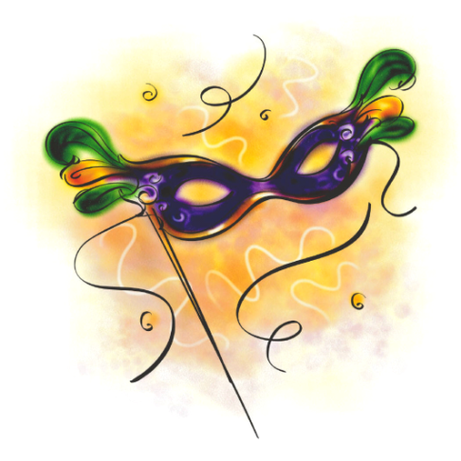Create a mask that incorporates these symbols and colour it in with crayons, markers, or pencil crayons. It is not about your artistic skills here; however, you should have a presentable and polished mask not something that appears slapped together.

Writing the Paragraph

* The purpose of the paragraph is to prove that your symbols are the best representation for the character by using evidence from the text.
* Include a topic sentence that introduces the character, play and your symbols.
* Include three Point, Proof, Explain+Analyze (1 PPE for each of your three symbols).
* Include a concluding sentence to wrap-up your argument
* Do not use I think, I picked, I chose, me, we, my. Use objective language.
* Use transition words to link your ideas.
* Use vocabulary and diction that is concise and sophisticated.

|  |  |  |  |
| --- | --- | --- | --- |
| **Level 4**  **100-80%** | **Level 3**  **79-70%** | **Level 2**  **69-60%** | **Level 1**  **59-50%** |
| **Knowledge and Understanding** | | | |
| Sophisticated knowledge of text, characters, and plot.  10 9 8 | Good knowledge of text, characters, and plot.  7.9 7.5 7 | Some knowledge of text, characters, and plot.  6.9 6.5 6 | Limited understanding of the text, characters and plot.  5.9 5.5 5 |
| **Thinking** | | | |
| Symbols are highly original and are sophisticated in connection to the character. Demonstrates a close reading analysis for each symbol.  10 9 8 | Symbols accurate and relevant to the character. Demonstrates analysis for each symbol.  7.9 7.5 7 | Symbols are somewhat accurate and somewhat relevant to the character. Demonstrates some analysis for each symbol.  6.9 6.5 6 | Symbols are limited in scope and don’t connect well with the character. Analysis is simplistic for each symbol.  5.9 5.5 5 |
| **Communication** | | | |
| Sophisticated use of diction. Ideas are fluid and extremely clear. Transition words are used to move seamlessly from one idea to the next. Sophisticated use of vocabulary.  10 9 8 | Considerable use of diction. Ideas are fluid and clear. Transition words are used to move from one idea to the next. Considerable use of vocabulary.  7.9 7.5 7 | Some use of effective diction. Ideas are clear at times. Transition words are used at times to move from one idea to the next. Some use of adequate vocabulary.  6.9 6.5 6 | Limited grasp of diction. Ideas are often unclear. Transition between ideas is ineffective. Limited use of adequate vocabulary.  5.9 5.5 5 |
| **Application** | | | |
| Applies format with sophistication. Quotations are introduced with sophistication and in-text citations are correct. Mask is assembled with detail and accuracy.  10 9 8 | Applies format correctly. Quotations are introduced and in-text citations are correct. Mask is assembled with care.  7.9 7.5 7 | Some application of correct format. Quotations are introductions and in-text citations contain some errors. Mask is somewhat organized.  6.9 6.5 6 | Limited application of correct format. Limited introduction of quotations and in-text citations contain frequent errors. Mask disorganized.  5.9 5.5 5 |